PPC ADVERTISING PACKAGES

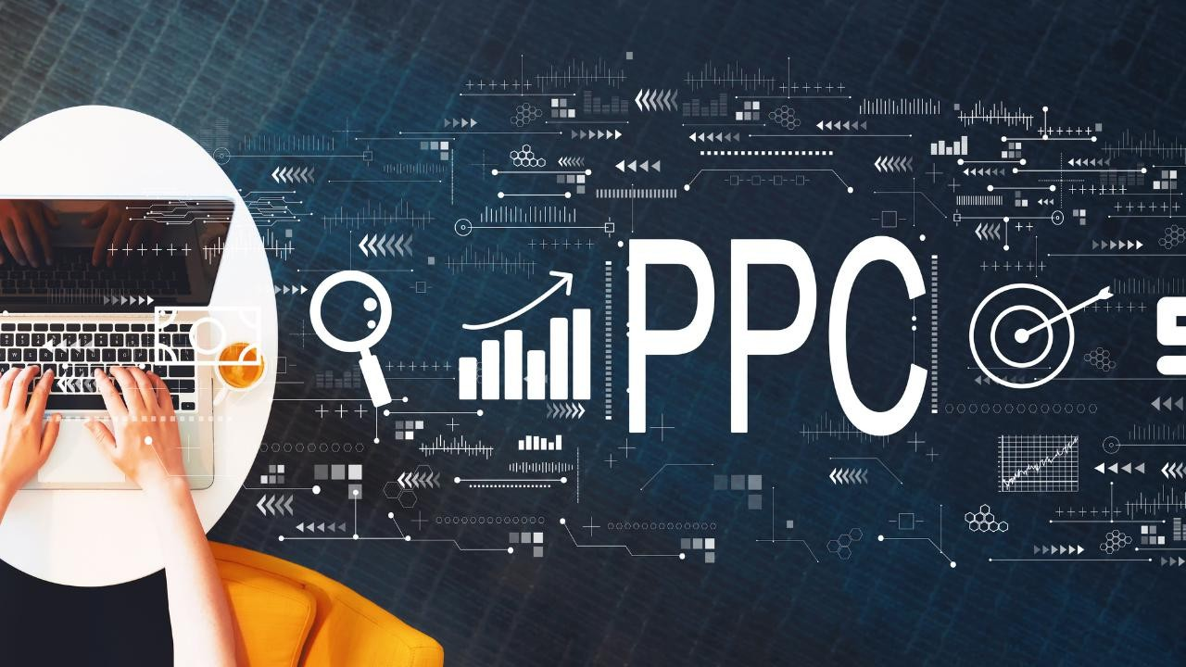

Pay-Per-Click, or Paid Search, is online advertising in which an ad for your product or service appears on the first page of Google when people search on keywords that are associated with your business.

Social media platforms (Facebook, Instagram, Twitter, Linkedin) and other search engines (Bing) offer PPC opportunities too. You are charged each time someone clicks on your ad.

# Features and Benefits of Pay-Per-Click:

* Works fast! Your ad can begin running the day the campaign is launched.
* You set your budget and maximum cost-per-click you’re willing to pay.
* Campaigns can be targeted to precise geographic areas and set to run on days/times of your choice.
* Retargeting campaigns show highly targeted ads to people who have visited your website.
* Google Display Network campaigns show your ads on websites that are relevant to your products and services.
* Ads can be targeted to mobile devices.
* Cost per lead is often less than other forms of advertising.
* Keyword performance can be strategically utilized to increase effectiveness of SEO campaign.
* Ideal supplement to an SEO campaign--immediate online visibility while your SEO campaign is ramping up.

PPC is one of the most measurable and effective advertising channels available to businesses today. We specialize in making sure your business gets the

unique strategy it needs to create success, along with professional account management and optimization.

We know that starting with PPC for the first time can be daunting; we aim to take all of that away. We will make sure your account is set up in a way that perfectly fits your budget, brand and business goals.

We're always honest about what you can expect from your campaigns, and are here for you, whatever you need.

# PPC SERVICES INCLUDE

|  |  |
| --- | --- |
| Keyword Research Competitor Analysys Account Manager Set Up  Conversion Tracking Set Up | Google Analytics Set Up Advice Campaign Creation Ad Copy Creation  Ad Extension Creation |

50,000



The startup paid marketing package is designed for startups or small businesses interested in primarily seeking top-of-the-funnel (TOFU) execution and support in building website traffic, subscribers, and reach. Great for basic overall marketing consult and support, or specialized services.

|  |  |
| --- | --- |
| * **Campaigns Creation & Management -1** * **Ad Group Setup - 2** * **Search Ads, Display Ads Setup** * **Keywords Research & Planning** * **Ad Copies – Up to 5** * **Weekly Work Report** | * **Competitor Analyses** * **Keywords / Ads Optimization** * **No. of Keywords – Up to 30** * **PPC Account Setup (1 platform from FB/Insta, Google Adwords, Linkedin etc.)** * **Conversion Tracking** * **Phone / Email Support** |

* Includes monthly Ad Budget Spending of INR 25,000



The advance paid marketing package is designed for established small & medium businesses interested in primarily seeking top-of-the-funnel (TOFU) execution and support in building website traffic, subscribers, and reach. Great for advance overall marketing consult and support, or specialized services.

75,000

|  |  |
| --- | --- |
| * **Campaigns Creation & Management -2** * **Ad Group Setup - 4** * **Search Ads, Display Ads Setup** * **Keywords Research & Planning** * **Ad Copies – Up to 10** * **Weekly Work Report** | * **Competitor Analysys** * **Keywords / Ads Optimization** * **No. of Keywords – Up to 60** * **PPC Account Setup (2 platforms from FB/Insta, Google Adwords, Linkedin, Twitter etc.)** * **Conversion Tracking** * **Phone / Email Support** * **ROI Analysys** * **Landing Page Optimization** |

* Includes monthly Ad Budget Spending of INR 40,000

*To request this Package, contact us by mail at [info@resqore.com](mailto:sales@sivaomarketing.com)/marketing.playzone@gmail.com or call at +918882023943/+91- 9266368290 to discuss your requirements. We are also available to discuss your project via Zoom or Google Meet.*

1,00,000



The advance paid marketing package is designed for established medium & large businesses interested in primarily seeking top-of-the-funnel (TOFU) execution and support in building website traffic, subscribers, and reach. Great for industry leading marketing consult and support, or specialized services.

|  |  |
| --- | --- |
| * **Campaigns Creation & Management -4** * **Ad Group Setup - 8** * **Search Ads, Display Ads Setup** * **Keywords Research & Planning** * **Ad Copies – Up to 20** * **Weekly Work Report** | * **Competitor Analysys** * **Keywords / Ads Optimization** * **No. of Keywords – Up to 100** * **PPC Account Setup (3 platforms from FB/Insta, Google Adwords, Linkedin, Twitter etc.)** * **Conversion Tracking** * **Phone / Email Support** * **ROI Analysys** * **Landing Page Optimization** |

* Includes monthly Ad Budget Spending of INR 60,000

*To request this Package, contact us by mail at [info@resqore.com](mailto:sales@sivaomarketing.com)/marketing.playzone@gmail.com or call at +918882023943/+91- 9266368290 to discuss your requirements. We are also available to discuss your project via Zoom or Google Meet.***THE QUICK BASICS**

There are a lot of terminologies used around digital marketing and it's very essential to know the basics to start with. This helps you to understand the terminologies and tools we’ve mentioned in the packages.

**SEO Services (Search Engine Optimization) -** SEO services enables you to understand or definehow your customer searches for you andreaches you via searchengines. By having a clear SEO plan you can improve your visibility andranking in search results

**SEM Services(Search Engine Marketing) -** SEM is thepractice of using paid advertisements to appear on search engines results page.

**PPC (Pay Per Click) -** PPC is onemodel of internetmarketing wheretheadvertisers pay a fee every time their ad gets clicked Local Search Marketing Services -

**Local SEO** – Local SEO services enable you to finda place in thelocal competition and promote your business online, locally

**Content Marketing Services -** Content marketing services help you to promote your business via content. Contentheremay refer to blogs, ebooks, white papers, vlogs, infographics and much more

**SMM (Social Media Marketing) -** All theads, posts you see in social media areaimed at pulling your attention towards their brand or products. How many products have you known or bought just by seeing a facebook or an instagram ad? Worth a thought right?

**Marketing Automation -** Marketingautomation is theprocess by which you define the customer journey and behaviour with help of a CRM. Imagine you have a big customer baseand you plan to nurtureall your prospectiveleads on a daily/weekly or monthly basis. Amarketing automationtool will be of greathelp. Inaddition toall theabovelistedtactics, thereareremarketing, influencer marketing, online PRs, affiliate marketing, online reputation management, voice based marketing, AR/VR marketing etc.

**DIGITAL MARKETING POLICIES**

During the provision of the Works by Playzone Media to the Client, the Client shall not:

* Employ the services of any Search Engine Optimisation or Pay Per Click Company other than Playzone Media to work on their website promotion;
* Employ the services of any Submission Company other than Playzone Media for the provision of their Search Engine Optimisation services;
* Create any duplicate sites, duplicate content or pages, redirects or doorway pages to their website;
* Request or exchange links with any link farms or undertake any spamming techniques which may harm the website’s search engine ranking with Google.
* The Client shall grant the authority to submit the web site pages being promoted to search engines, directories and other web sites. The Client shall provide Playzone Media with log-in information (FTP username and password) to allow us to gain access to the Client website.
* The Client shall be responsible for informing as required by their webmaster or anyone else who has access to their website, that Playzone Media are performing Search Engine Optimisation or Pay Per Click services on their site.
* The Client shall inform Playzone Media of any change or changes made to their website throughout your Search Engine Optimisation or Pay Per Click campaign within 24 hours of such change or changes being implemented.
* The Client shall grant the authority to connect accounts, including pay per click accounts and Analytics accounts to 3rd party tools/services for the purpose of administering the accounts, reporting and improving performance through bid management for example.
* Playzone Media does not offer credit terms. Playzone Media shall issue invoices on a monthly basis for all Works provided to the Client in a particular calendar month.
* Invoices will be issued upon completion of the Works for that calendar month or at the end of the Engagement if sooner.
* In the event of non-payment of any invoice Playzone Media shall be entitled to withhold or suspend the provision of further Works until such time as it receives payment of the invoice or other payments due. In addition Playzone Media Ltd shall be entitled to retract the works provided to the Client and invoiced for under any unpaid invoice until such time as it receives payment of that invoice.

***OC-839, Gaur City Centre, Noida Extension, Noida, U.P.   
T: +91 8882023943***

***Emails: marketing.playzone@gmail.com***